Large Vietnamese noodle soup with rare steak

|  |  |
| --- | --- |
| New York, NY | Denver, CO |
| 1. 7.25 2. 6.75 3. 6.00 4. 9 5. 10 6. 10 7. 12.5 8. 10 9. 9 10. 7.50 11. 10.50 12. 10 13. 8.25 14. 11 15. 15 16. 15 17. 14 18. 7.50 19. 14 20. 9.25 21. 10 22. 9 23. 12 24. 14 25. 9 26. 10.50 27. 14 28. 8.50 29. 10 30. 10 | 1. 8.95 2. 10 3. 8.75 4. 8.75 5. 7.95 6. 8.95 7. 10.00 8. 11.50 9. 9.50 10. 5.95 11. 6.95 12. 7.95 13. 8.95 14. 7.25 15. 9.00 16. 10 17. 8.25 18. 9.95 19. 9.50 20. 8.75 21. 6.75 22. 9.45 23. 9.50 24. 8.50 25. 8.95 26. 8.95 27. 7.75 28. 9.25 29. 9.95 30. 10 |

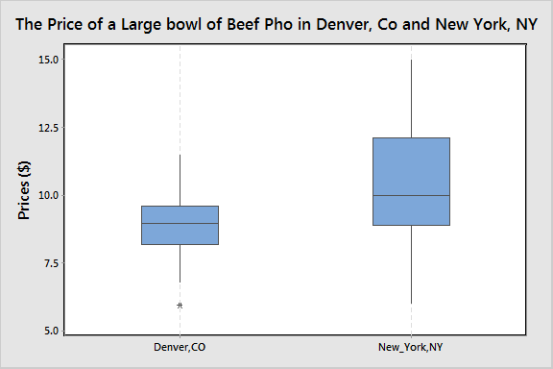

New York, NY

Mean: 10.317

Standard deviation: 2.486

Denver, CO

Mean: 8.863

Standard deviation: 1.158

Five number Summary:

New York

(6,9,10,12,15)

Denver

(5.95,8.25,8.95,9.50,11.50)

Confidence Interval at confidence Level 95%

New York, NY

α = .05

t.025,29 = 2.045

mean = 10.317

s = 2.486

10.317 ± 2.045 * ($\frac{2.486}{\sqrt{30}}$) = (9.389, 11.245)

Denver, Co

α = .05

t.025,29 = 2.045

mean = 8.863

s = 1.158

8.863 ± 2.045 * ($\frac{1.158}{\sqrt{30}}$) = (8.431, 9.295)

Hypothesis test

Ho: µ0 - µ1 = 0

Ho: µ0 - µ1 ≠ 0